**InsightStream**: Navigate the News

Landscape (React Application)

Introduction:

In our daily lives, we come across various events of local as well as national importance, and to know it, we take the help of NEWS. But recently we realized there is no such common platform that provides both. So we found a social need and built a platform that provides such news in the form of short videos that are taken from the most trusted resources in the world.

**Design Process**

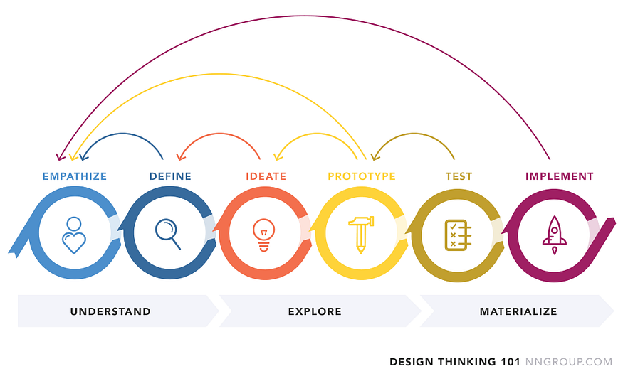

**01. EMPATHIZE**

We examined the pain points of our target audience. Hence we can fit into their life instead of just urging our app.

**How do people watch the news currently?**

1. Facebook

2.Youtube  
3. Instagram  
4. Google  
5. WhatsApp  
6. Television

**02. DEFINE**

I started drawing out solutions on Figma to give freedom to my flow of thought and not be constrained by details.

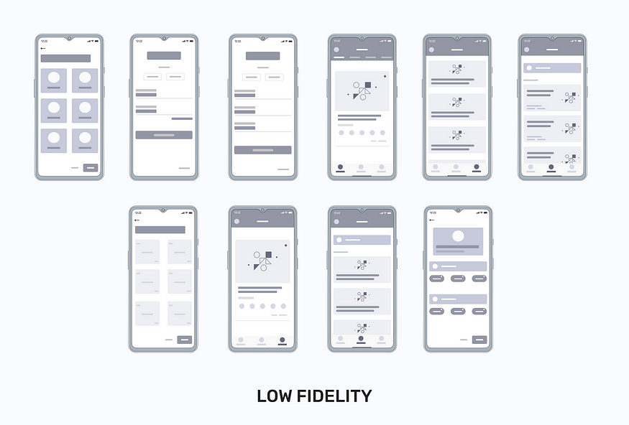

**Point #1: Login**

Login is available with Google, Facebook, and Gmail. If the user doesn’t want to log in, he can choose to skip but they can’t see their regional and preferred topics news.

**Point #2: News-Feed (Homepage)**

The “News-Feed” page is where users are supposed to get news recommendations based on their preferences. However, users were still switching to a different section and a different topic of news.

**Point #3: Search**

The search page was a place where the user would want to discover a new topic to watch but the issue is they didn’t know what to search so for them we provided some current topic suggestions to make it easier to choose and get fast results.

**Point #4: Save (previously Bookmark)**

The bookmark page was where the user saves their videos which they like to watch again later. However, if the user saves many videos we add a search feature to find their saved result.

**Point #5: Customize**

Since the app is multilingual, provides regional(local) news, or provides some preferred topics we have to give them customizable options(like choosing more than one local place or topic) to easily select their needs.

**03. IDEATE(MID-FIDELITY)**

**Creating a Card System**

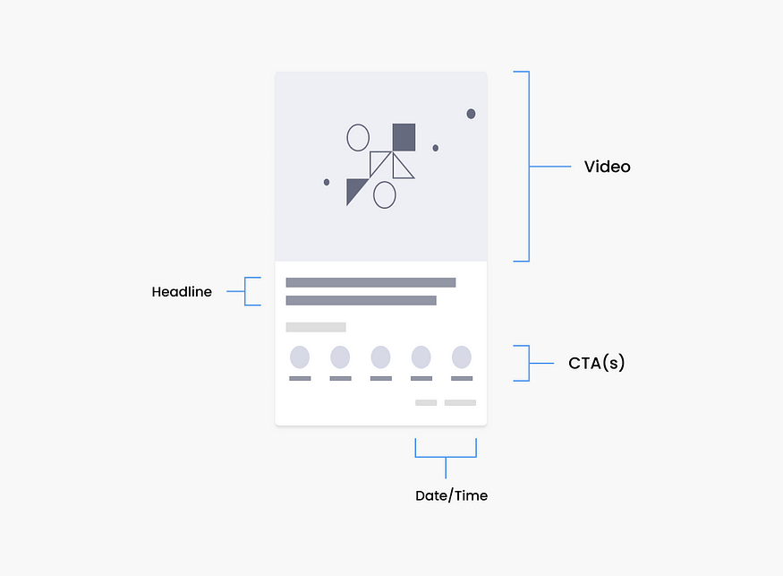

After completing the low-fidelity there is a lot to finalize before the developers start working on the pilot version of the app. There is a need for a card design system that makes content easily scannable and developers to build.

**04. FINAL UI**

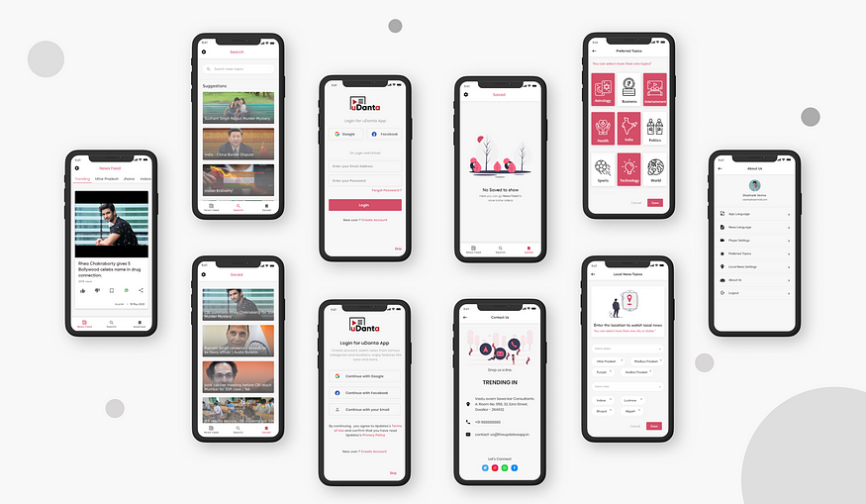

**05. TESTING AND VALIDATION**

After creating the Final UI and Prototype, the design goes into the development phase, and then we will proceed to the MVP phase where we [test](https://medium.com/design-bootcamp/the-power-of-benchmarking-user-tests-d36cd426a7ba) our app on around 20–30 people to test my design solutions with our target audience they gave us some valuable pain points which I ignored while designing this app

**UX Writing Issues**

Challenge 1: Bookmark Page was the most confusing for most of our users. They don’t know how to save the video and where to find it.

Solution: I changed the Bookmark into Saved and also made some changes to the card design. We are currently working on providing a little guide overview for the user when they come for the first time on the app, this thing will come soon in future updates.

Challenge 2: The search Page is the place where people are stuck most, they can’t understand what to search for in the search section(for example, they have to search for some topic? or they have to search for some video headline?)

Solution: So we came up with an idea to provide users with some suggestions from the current news hot topics and also change the placeholder of the search bar.

**Other Problems encountered**

* First, we give less control over video player settings to our users but further, we find that different people have different requirements so we have provided some extra player features to change the settings according to/their needs.
* Since our target audience is also from rural cities, where people find some difficult to understand some terms in English we add the multilingual feature.

**06. IMPLEMENTATION**

After the first release, some mobile app screens are down below.

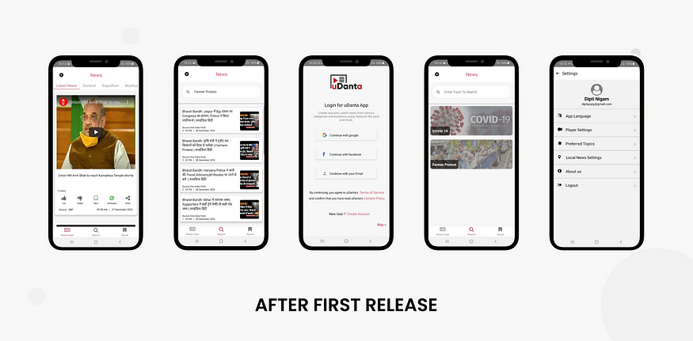

**What I Accomplished**

1. Simplified interface of the app.  
2. Android/IOS Mockups and design guidelines.  
3. Easy multilingual interface.

**Conclusion**

From the results of the testing in the MVP phase, it can be concluded the design that I proposed can further enhance the user experience and it still needs to be iterated for several points.